Program Aided Language Models (PAL)

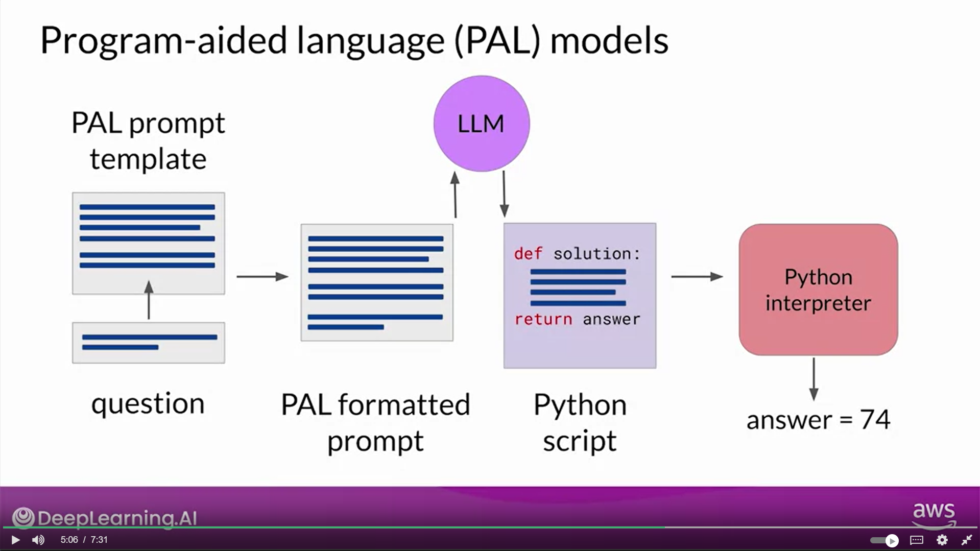

PAL Architecture

